# Setting to be done for attaching file/files in soap UI request:

Below setting needs to be done in soup UI tool along with normal input data that will be keyed in from data source.

Settings:

* Set “Enable MTOM” property to **true**.
* Set “Disable multiparts” to **false** to associate multiple files with the same attachment part.
* File content that needs to be attached shall be included in attachment tab at the bottom of the request editor in the test cases of that operation.
* File name is prefixed with [**cid:**](cid:%3cattachment%20name%3e) notation in input data file, this prefix will set its type to “CONTENT”.

Note: For redistribution of same file Cached option shall be selected else, do not select Cached option.

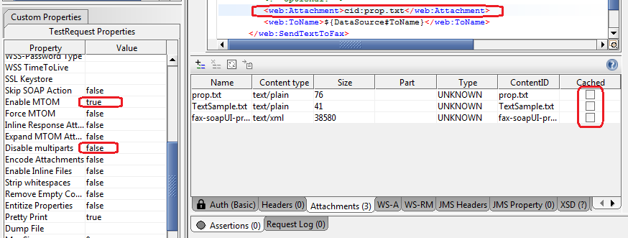

*Reference:*

<http://www.soapui.org/SOAP-and-WSDL/adding-headers-and-attachments.html>

# Soap UI unable to connect to internet or Connection refused error:

Locate “SoapUI-5.0.0.vmoptions” file in soap UI bin folder (C:\Program Files\SmartBear\SoapUI-5.0.0\bin).

Add “-Djava.net.preferIPv4Stack=true” line (without quote) to the file.

# Add Script library (external class file):

**Need for Script Library:** Used to save common class files and can be referred in different groovy scripts. This will reduce repeatability and increase reusability.

* Make new folder (e.g. "C:\GroovyLib"), Add groovy class file into the folder, “CommonUtils.groovy”.
* Set File > Preferences > SoapUI Pro tab > Script Library to library folder. (I would set that to "C:\GroovyLib" in my example.)
* Then restart SoapUI Pro to pick up the library script.
* Call Groovy as follow(new groovy file)

// CommonUtils.groovy

c = new CommonUtils()

# Eclipse java configuring property

File: eclipse.ini

-vm

C:/Program Files/Java/jdk1.6.0_32/bin/javaw.exe